Selection Sort

Working Logic:
- Select the smallest value in the list.
- Swap smallest value with the first value of the list.
- Again select the smallest value in the list (exclude first value)
- Swap this value with the second element of the list.
- Keep doing n-1 times to place all n values in the sorted order.

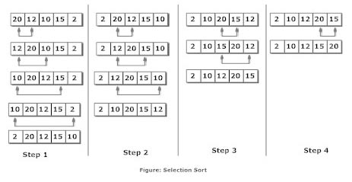

Programing Example:
#include <stdio.h>

int main()
{
int array[100], n, c, d, position, swap;

printf("Enter number of elements\n");
scanf("%d", &n);

printf("Enter %d integers\n", n);

for ( c = 0 ; c < n ; c++ )
scanf("%d", &array[c]);

for ( c = 0 ; c < ( n - 1 ) ; c++ )
{
position = c;

for ( d = c + 1 ; d < n ; d++ )
{
if ( array[position] > array[d] )
position = d;
}
if ( position != c )
{
swap = array[c];
array[c] = array[position];
array[position] = swap;
}
}

printf("Sorted list in ascending order:\n");

for ( c = 0 ; c < n ; c++ )
printf("%d\n", array[c]);

return 0;
}

